James Ekstract

Professor Arias

CMPT220-111

20 January 2017

Assignment 0

1. Setup Java – VM and compiler versions

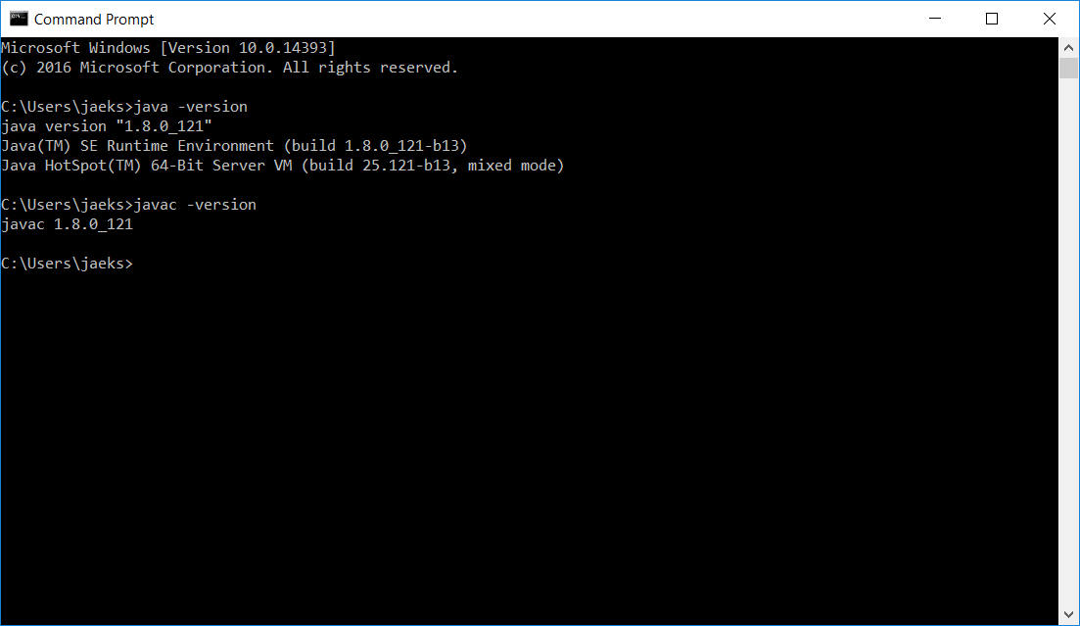

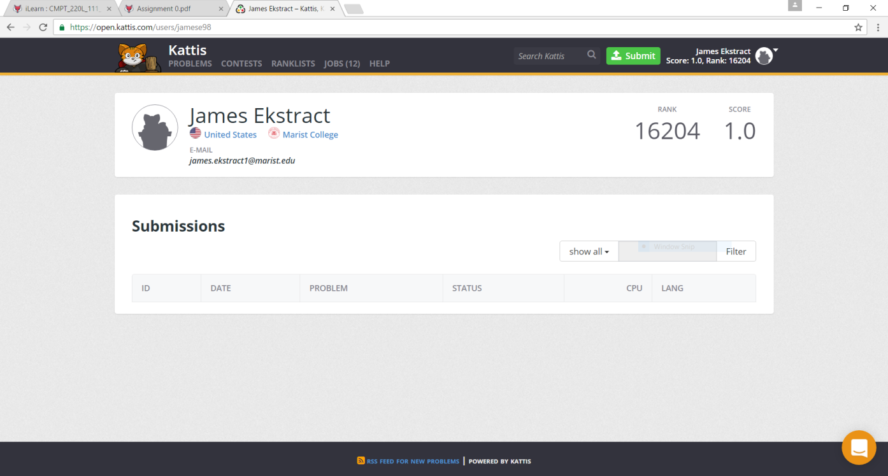

2. Create an account on Kattis

3. Create GitHub account

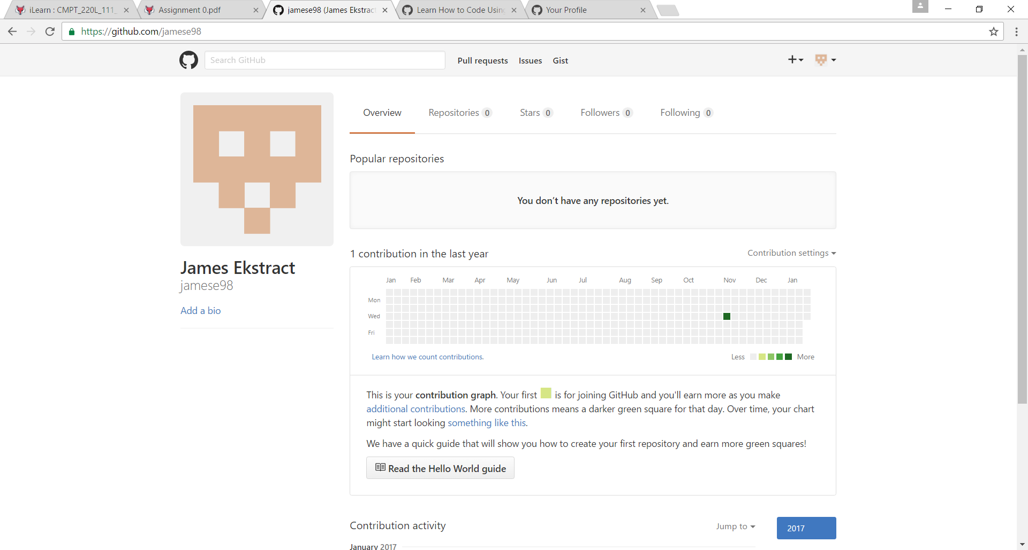

4. Create GitHub repository

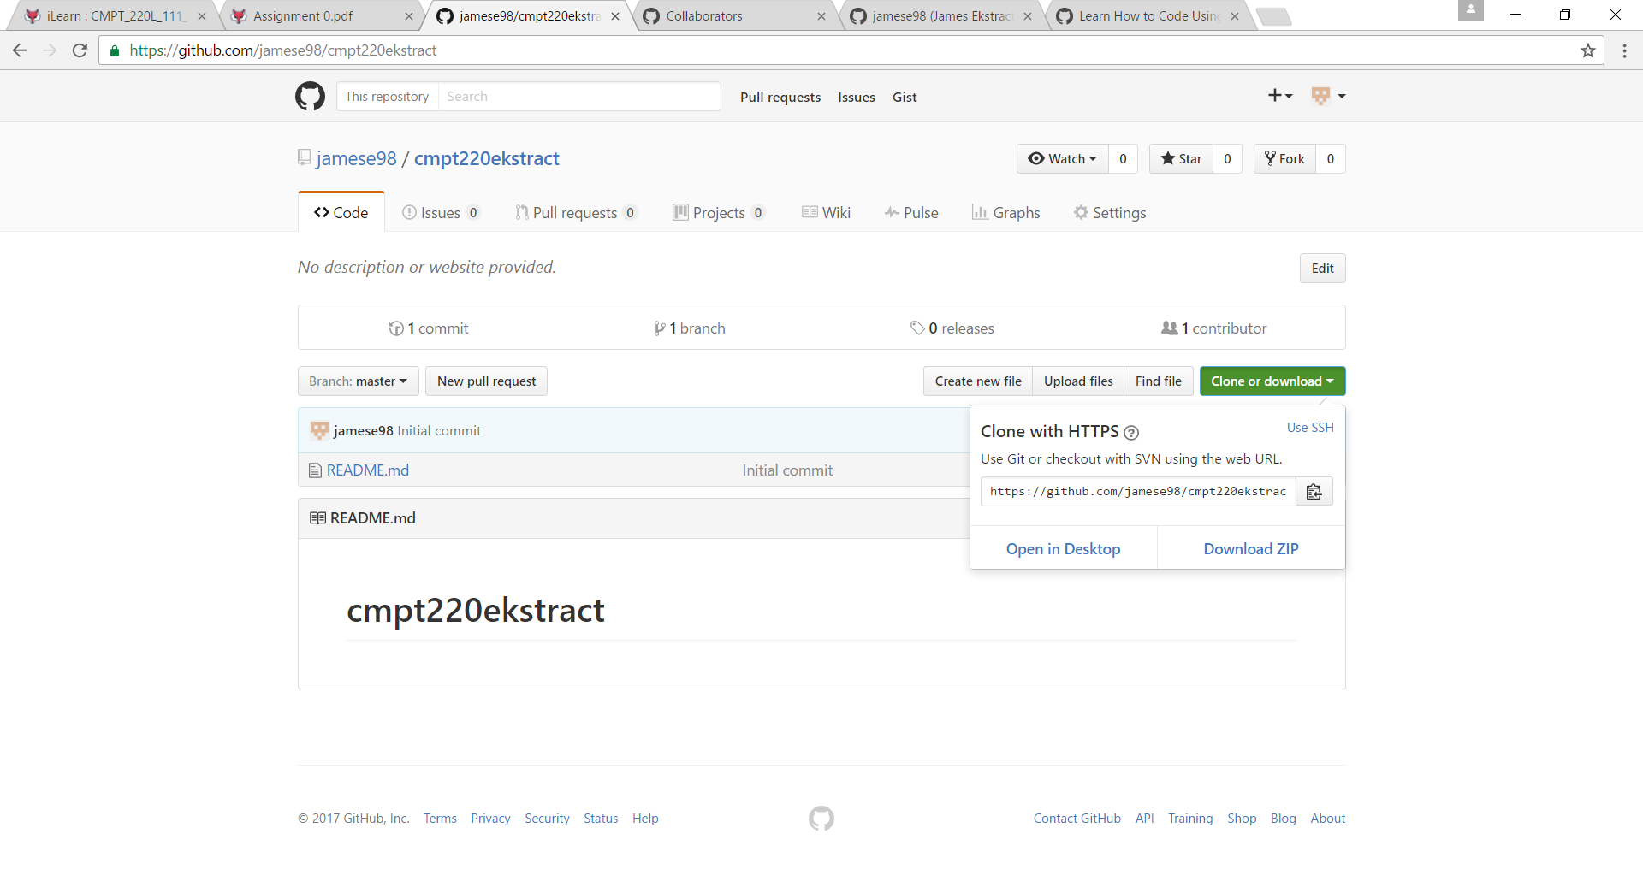

<https://github.com/jamese98/cmpt220ekstract.git>